***Edge/Fog Computing***

Visual Programming - BSE-5B

Bachelors in Software Engineering

Semester: Fall-2018

Teacher Name:Engr Faisal

Lab Engineer: Engr Ramsha Masood



# **Introduction:**

Computers have come a long way since their creation in the late 90’s. Computer have evolved from their size,shape to the way they function and are used.Even today computer have been evolving way past their current set limits and creating more and more possibilities for us humans to achieve.Computing has come a long way from isolated computing to distributed computing to centralized computing and now to cloud computing. However we have now found to make distributed computing more efficient through the introduction to cloud/fog computing which specialized I pushing functionality to the end devices of the network easing somewhat strain on the Server or Cloud.We will now go further in depth

# **What is Edge/Fog Computing?**

Edge/Fog Computing Involved pushing some major functionalism to the Edge/Fog or to the the end devices of a network so that the Edge/Fog devices alone can make important calls and decision based their functionality rather then send data to the server or the cloud and wait for them to take decision on the gathered data. This will reduce the amount of data transfer within the network and also reduce strain on the server.

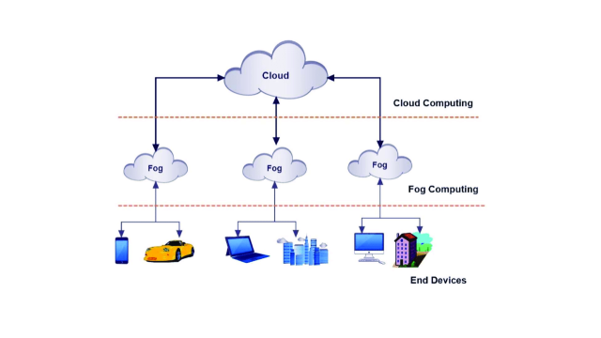

**For e.g:** Taking the example of a surveillance camera normally before the use of Edge/Fog computing what the camera use to do was act as dumb terminals and just simply broadcast data to the main server 24/7 and then the server use to monitor the data and take decision if it find anything in it. This was very inefficient and would put a huge load on the server since it will have to monitor data from multiple surveillance cameras at the same time and in addition since data is being transfer within the network all the time this will cause the speed problems.



# **Advantages and Disadvantages of Edge/Fog Computing?**

**Advantages:**

1. **Reduces Load on Server**

As stated above server done have to do everything since the end devices are capable of performing important functions themselves

1. **Reduces Load on Network**

As stated above less data transmission means lesser strain on the network

1. **Offer New Functionality**

By making end devices smart we simultaneously adding newer functionality to our system since our smart devices will be capable of doing stuff like hear detection.,Motion Detection , Image Recognition etc.

**Disadvantages:**

1. **Bad Configuration is easier**

By giving our end devices many new features and functions we are also giving our selves more configuration of those devices.Its not that configuration is difficult but configuring many features of many devices may lead to some vital mistake that may cost you

1. **Hacking Vector Increased**

Since we are making our devices smart and depending on them to do half the work for us that mean that if an hacker takes out your device you are to lose a lot and the hacker has to gain a lot. Therefore devices like these should have a much tighter security.

1. **Licensing Costs**

Devices Capable of doing so many functions don’t come cheap. Especially when you have to purchase many of these devices.

With Edge/Fog Computing the Surveillance Camera would become so Smart that they will be able to detect suspicious activity by themselves and take Decision Accordingly by sendig only that data the camera deem worthy.

# **Future of Edge/Fog Computing?**

With the rise of IOT many organizations are adopting the use of Edge/Fog computing in their networks

Many software applications too are becoming distributed across multiple regions and multiple cloud providers. This app distribution exercise is forcing developers to rethink high-availability and security strategies across all of their points of presence in the cloud.

Plus, with apps consuming and generating massive amounts of data, developers have to investigate new ways to process these sizeable and potentially distributed data streams to create value.

Smart Health management Devices.

Disaster Management.

Oil and Energy.

Smart Drones.



**Conclusion:**

Egde/Fog Computing is surely a very big step forward and will surely open more doors of further un doable possibilities to surpass. However each step is also a step backwards since as mentioned relying too much on these machines may be costly therefore it is dangerous to become to just careless of our soundings and just let the machines handle everything. So will continue to develop and take further step forwards but also keep in mind that these machines that we make can never surpass what our creator has given us.